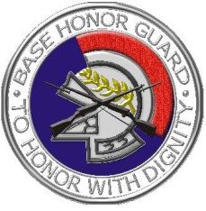
Scott AFB Honor Guard
Colors Request Form
As mandated by Congress, the Scott AFB Honor Guard’s primary duty is to provide Military Funeral Honors to our veteran, retiree, and active duty members. Due to the unpredictable nature of our Military Funeral Honors schedule, colors requests are not fully committed to until 24 hours prior to the requested event.
We only perform promotions and retirements for GS-15’s, E-9’s, O-6’s and above. If the member’s rank is insufficient for us to perform at the ceremony, we can train selected unit personnel on how to conduct the presentation of colors and flag fold.
There is no longer an official flag folding script to be used during the folding of the flag. Also, if a flag is not provided by the retiree to be folded, our Ceremonial Guardsmen will have to retrieve the HG-owned flag after the ceremony.

TYPE OF EVENT
- Retirement of:__________________ Years Completed:____ Unit Retiring from:_________
- Promotion of:___________________________ To what rank: _______________________
- Change of Command:_______________________________________________________
- Other:____________________________________________________________________
- Flag fold: YES / NO
- General Officer flag require?: YES / NO
  - If yes, which flag? __________________
Location: _________________________________________________________________________
(PROVIDE EXACT ADDRESS FOR GPS PURPOSES)
Event Date: _______________________ Event Start time: __________________________
POC name / number: ____________________________________________________________
Other info: ________________________________________________________________________

HONOR GUARD CONTACTS | Office: 618-256-4586 | Fax: 618-256-7462
Email: 375fss.honorguard@us.af.mil

